Calculating Cyclomatic Complexity:

Command radon cc directoryname -a

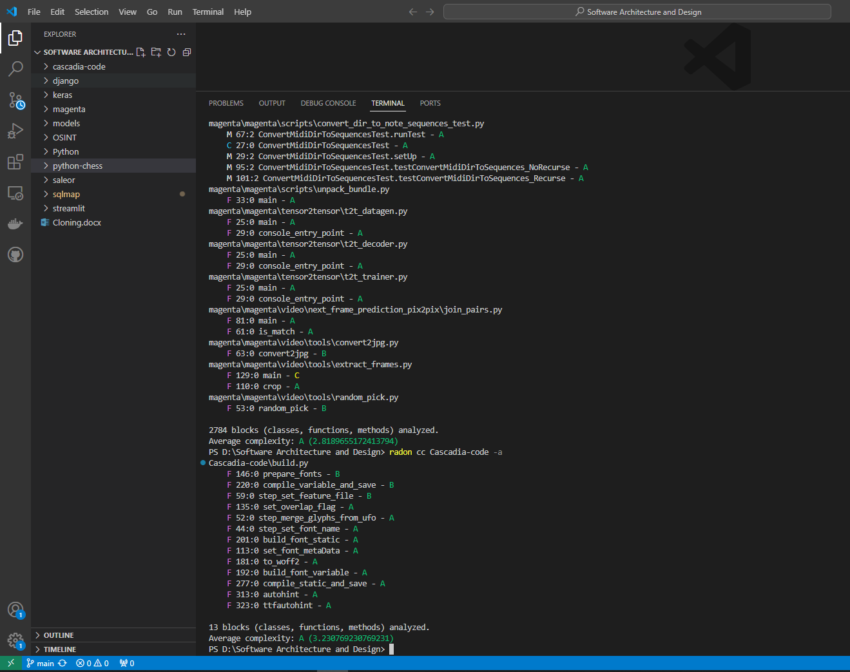

Radon cc sqlmap –a

3271 blocks (classes, functions, methods) analyzed.

Average complexity: B (5.125955365331703)

Radon cc django –a

34450 blocks (classes, functions, methods) analyzed.

Average complexity: A (1.8430478955007257)

Radon cc keras –a

9061 blocks (classes, functions, methods) analyzed.

Average complexity: A (2.316079902880477)

Radon cc OSINT –a

Error in python file

Radon cc python-chess –a

1410 blocks (classes, functions, methods) analyzed.

Average complexity: A (2.801418439716312)

Radon cc saleor –a

20668 blocks (classes, functions, methods) analyzed.

Average complexity: A (3.2475324172634026)

Radon cc streamlit –a

5530 blocks (classes, functions, methods) analyzed.

Average complexity: A (2.021157323688969)

Radon cc Python –a

1800 blocks (classes, functions, methods) analyzed.

Average complexity: A (3.062777777777778)

Radon cc models –a

20252 blocks (classes, functions, methods) analyzed.

Average complexity: A (2.4455362433339918)

Radon cc magenta –a

2784 blocks (classes, functions, methods) analyzed.

Average complexity: A (2.8189655172413794)

Radon cc Cascadia-code –a

13 blocks (classes, functions, methods) analyzed.

Average complexity: A (3.230769230769231)